
Assessment Cover Page
Student Full Name | Eusha Ibne Nur Sami
Student Number | 2024431
Module Title | Distributed Digital Transactions
Assessment Title | Ca-1(40%)
Lecturer/Supervisor | Dr. Muhammad Iqbal
Assessment Due Date | Friday, 13 November 2026, 11:59 PM
Date of Submission

Declaration of AI Use — AI Fluency Framework
This assessment applies to CCT College Dublin's AI Fluency Framework — four interconnected competencies that ensure your engagement with AI is effective, efficient, ethical and safe: Delegation, Description, Discernment and Diligence. Full detail on what AI use is permitted for this assessment, and the evidence you must provide, is set out in your Assessment Brief.
Delegation  Setting goals and deciding whether, when and how to engage with AI. | Description  Effectively describing goals to prompt useful AI behaviours and outputs.
Discernment  Accurately assessing the usefulness of AI outputs and behaviours. | Diligence  Taking responsibility for what we do with AI and how we do it.
Adapted from the AI Fluency Framework (Dakan, Feller, Anthropic, 2025).

Filling Out the Cover Sheet
- Fill out the top section of the cover page with all the required information.
- Complete the Student Response column of the AI Declaration table in the appendix of this cover, evidencing your Delegation, Description, Discernment and Diligence.

After reviewing the available project scenarios, I selected Food Traceability as the focus of my blockchain proposal. I will develop and evaluate a blockchain-based solution for improving transparency, traceability, and transaction integrity across the food supply chain.
Food Traceability Blockchain System

Introduction

Food traceability is the identification of a food product from its point of origin through its point of consumption. Information can be distributed independently along different links of a traditional food supply chain, between farmers, suppliers, distributors and retailers. This may make it challenging to track the origin of a product, and to know who had access and when it was passed from one to another. The idea is to implement a blockchain-based approach to establish a more transparent and reliable food traceability system.

Food supply system from today's perspective.

The current system involves several steps from the farmer, supplier, distributor, retailer and customer. Organisations are able to retain their own records. However, the full history of a product may take some time to find, since the records are kept separately. It can be challenging to determine the specific source of the error if it has been made or a product is recalled.

Current system issues:

The problems are basically lack of transparency, missing records, slow tracing, verification issues with product history and the potential for records being tampered with. There is also restricted access to trusted information regarding the origin and flow of food products to customers.

Proposed Blockchain Solution:

The proposed system will be a distributed, shared ledger between various actors in the food supply chain. Once a food product enters the system, it will be registered. The transaction will be recorded using a smart contract each time the product changes hands from one participant to another.

For instance, a farmer can register a product, a distributor can get it and a retailer can get it from the distributor, and the final record can be displayed by the customer. The blockchain will serve as an intermediary between the sender and receiver.

The system can store the product ID, Product Name, Product origin, current owner, sender address, receiver address, date and time and product status.

Smart Contract Design:

A food product function will be added to the Solidity smart contract to register a food product, transfer the product to another participant, update the food product and view the information regarding food products stored in the smart contract. The contract should also include the sender and receiver of each transaction.

Recent Blockchain Developments:

Such a system can be enhanced by recent blockchain developments. Smart contracts can execute transactions automatically, without any need for a central body to manually change all records. QR codes can provide customers with easier access to product information. Blockchain can also be integrated with IoT devices to gather data like location or temperature. The use of scalable technologies can also enhance the efficiency of blockchain systems in conducting transactions.

Benefits:

The advantage is greater traceability as the history of a food product can be traced from the source to the destination. Blockchain can also enhance transparency and data integrity and trust among supply-chain stakeholders. However, should a product recall occur, the recorded history can aid in quicker identification of the product.

Challenges:

Blockchain doesn't fix all the issues. Even if it is not the right information, it can be entered before reaching the blockchain. There may be costs associated with development, maintenance and transaction processing in the system. Privacy may be an issue if an organization stores sensitive business data on a public blockchain. However, achieving scalability and adoption can be challenging if not all organisations in the supply chain are not on the same system.

Cryptographic Security:

The system recommended will be based on cryptographic hashing and digital signatures. A hash function also ensures data integrity if the value of the data stored in the table changes, the hash value will also change. Public and private keys can be used to identify users, sign transactions. Digital signatures allow to demonstrate the authorization of a transaction with the appropriate blockchain account. In a Solidity system on the Ethereum blockchain, these security measures aid in authentication and transaction integrity.

Conclusion:

Using a blockchain based food traceability system could be a better solution to record the movement of the food products in a more transparent and verifiable manner. Smart contracts can facilitate the exchange between the sender and receiver, and the history of the transactions are recorded on the blockchain. There are of course problems to address, including data input inaccuracies, privacy concerns, and cost and adoption problems that must be taken into account in addition to the potential of the system to increase traceability and trust.

From balsamic wireframe i develop a Ui system to explain my project with : Food Traceability Blockchain System.
Please Find Attach below for review & proof of work : https://balsamiq.cloud/sids13h/pq58nq5
1.Consumer Dashboard: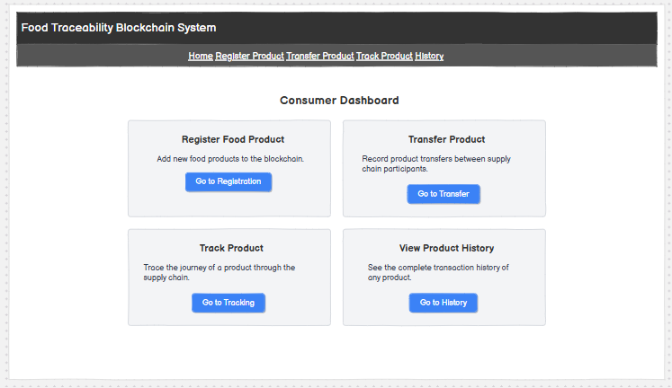2.Register Food Product 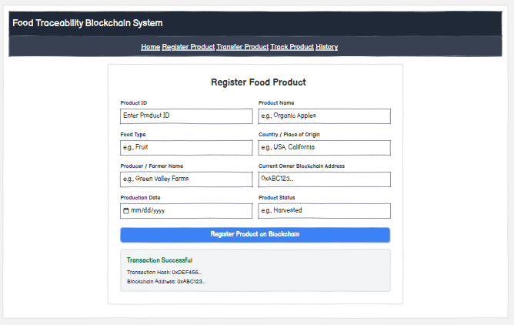3.Transfer & track the Product below : 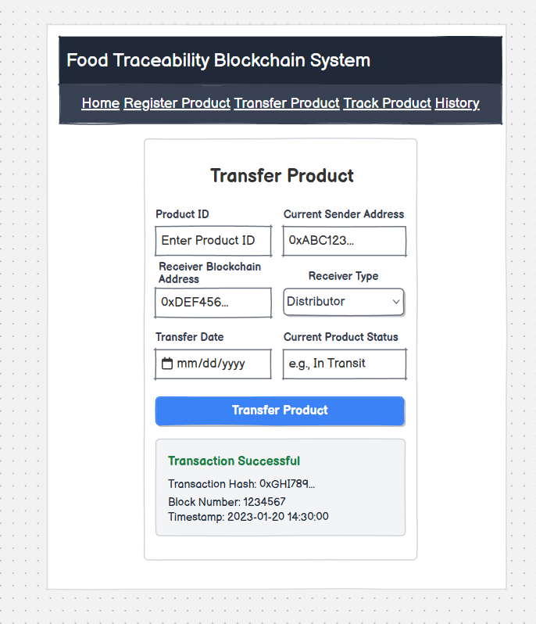4.ViewTransaction History: 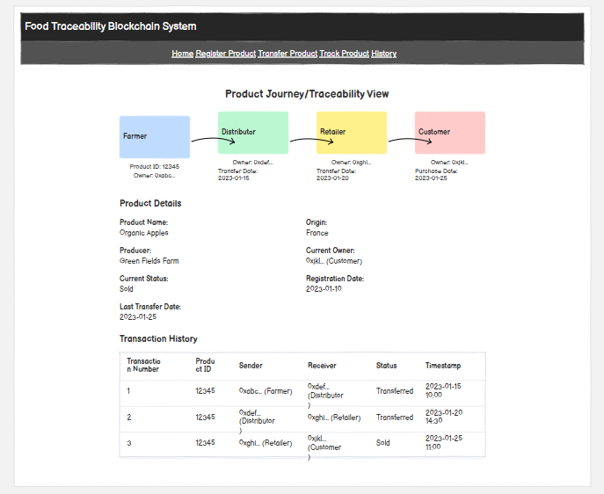

Solidity Smart Contract Development and Successful Compilation
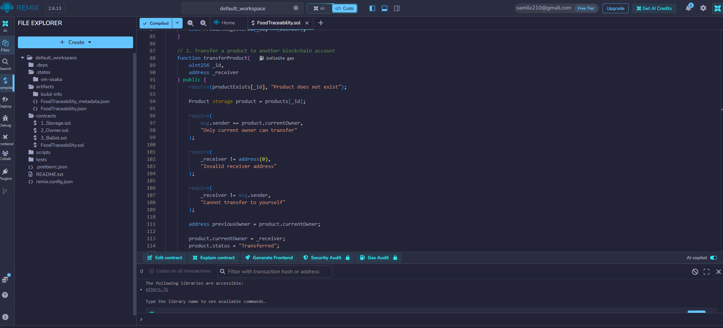
We've built the Food Traceability smart contract using Solidity in the online Remix IDE. There are functions for registration of food product, transfer of ownership, changing product status, finding product information, and viewing the transaction history in the contract.
Solidity compiler version 0.8.34 was able to compile the contract successfully. The Remix window displays no errors and it is able to recognize the smart contract name FoodTraceability.

Smart Contract Deployment Using Remix VM
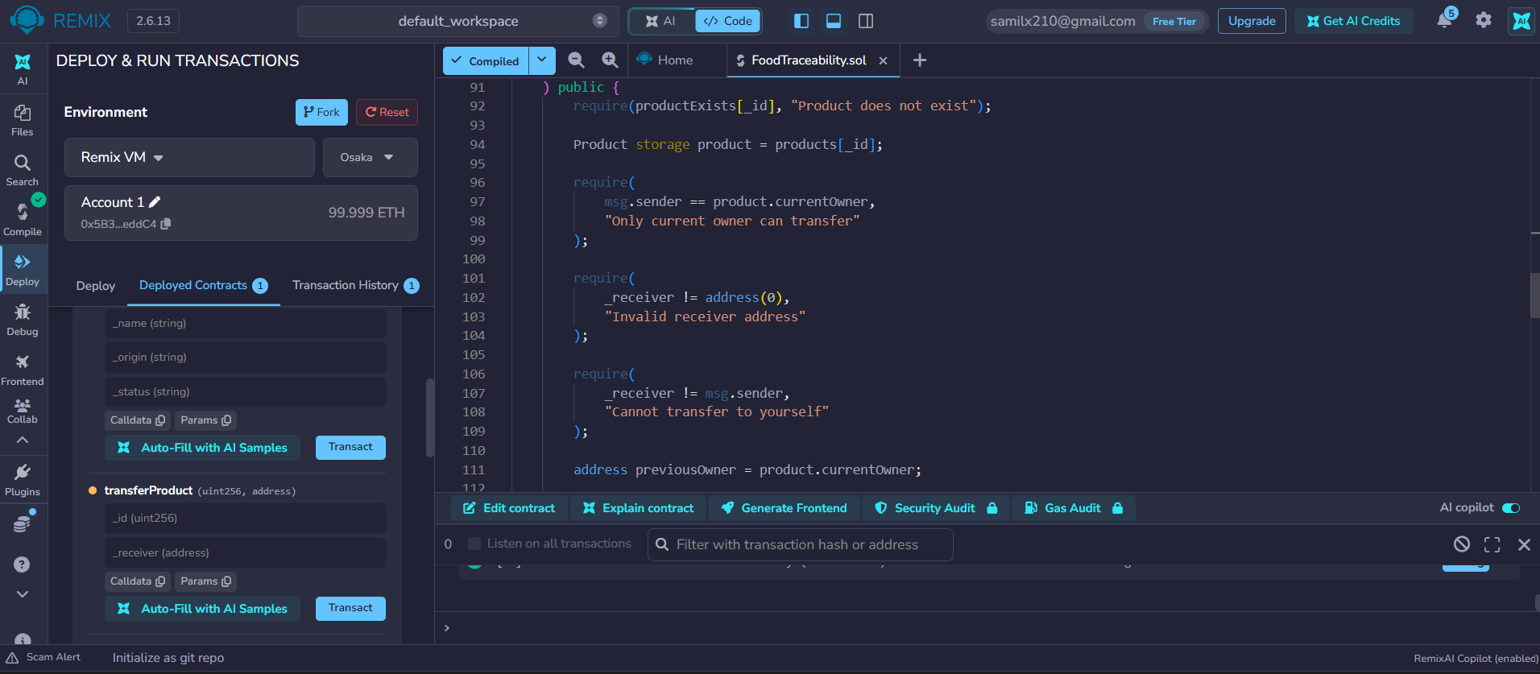

The Food Traceability smart contract was deployed using the IDe and virtual blockchain env, the deployment created a contract instance that can be used to test food product registration,ownership transfers,status updates and transaction history. The Screenshot shows One deployed and contract the initial blockchain recorded by Remix.

During Transact getting an error :
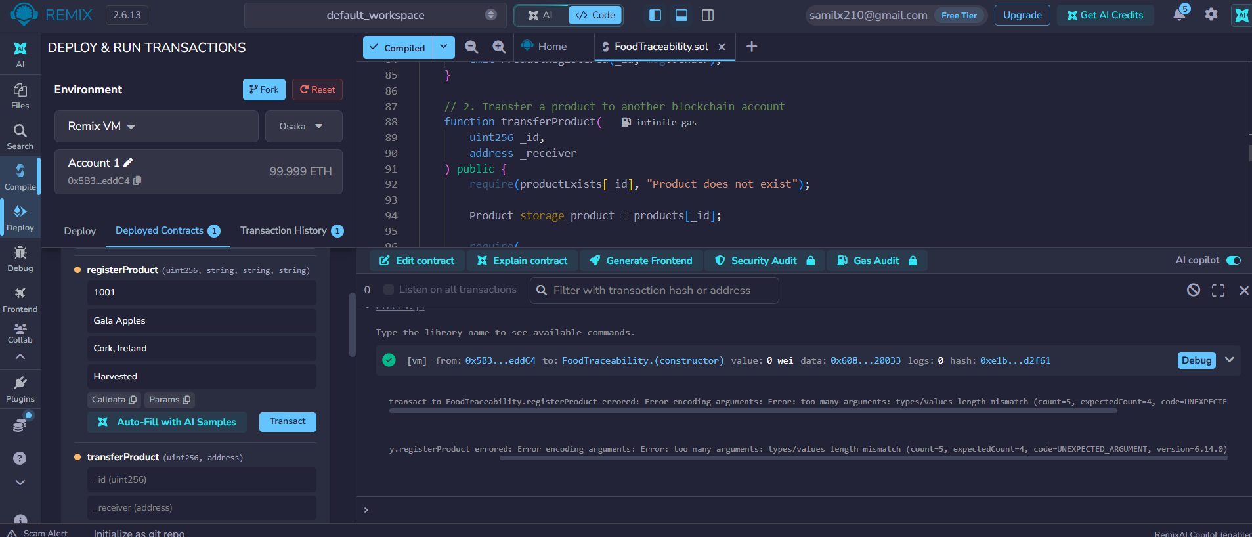

Error Says : transact to FoodTraceability.registerProduct errored: Error encoding arguments: Error: too many arguments: types/values length mismatch (count=5, expectedCount=4, code=UNEXPECTED_ARGUMENT, version=6.14.0)
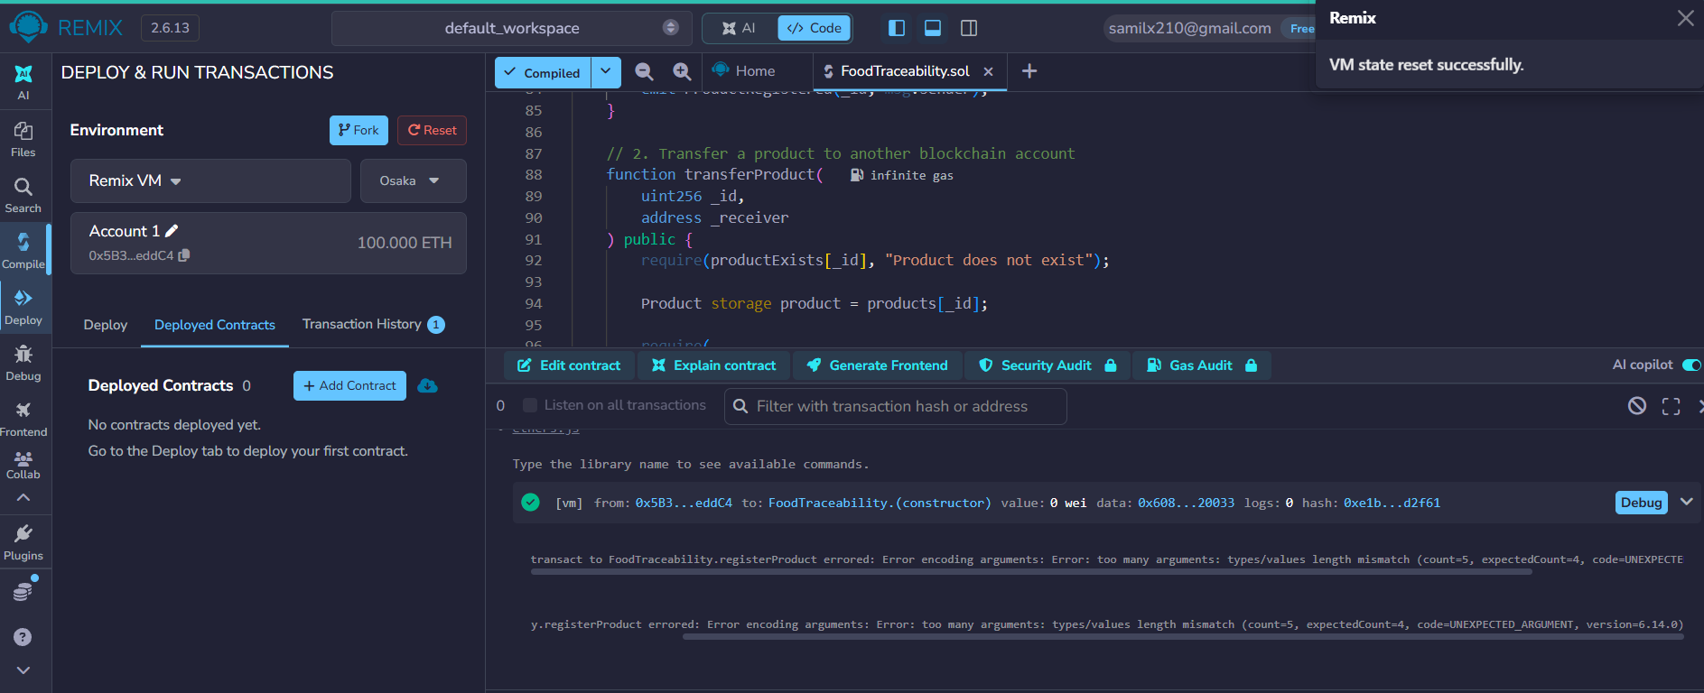
cleared the Old data and reset and redeploying for testing :

figure Out the “, ” = comma was the main culprit
refix and updated : 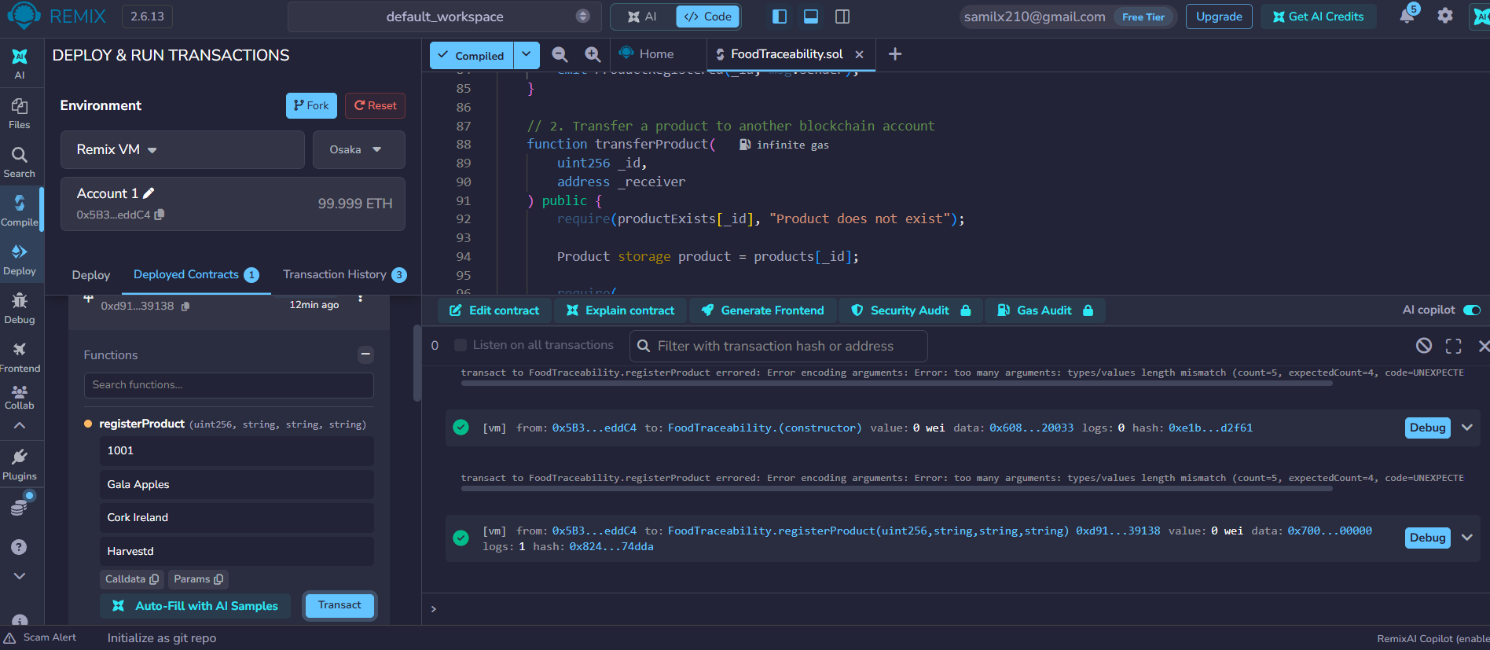
Successfully tested the registerProduct() function with Remix IDE. Product ID 1001 was registered and the status was Harvested, of Gala Apples, from Cork Ireland. It was done on the remix VM blockchain account #1.

The transaction was successful, creating a transaction hash and an event log that indicates that the smart contract received and logged the product registration.

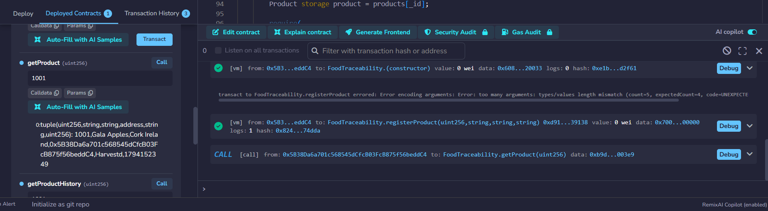
Tested the getProduct() function with Product ID: 1001 in Remix IDE. The smart contract was able to return the product information registered on it, such as the product name (Gala Apples), the origin (Cork Ireland), current owner of the blockchain, product status (Harvested), and the registration time (timestamp).

This test ensures that the blockchain smart contract can access the previously registered product information without altering the information.

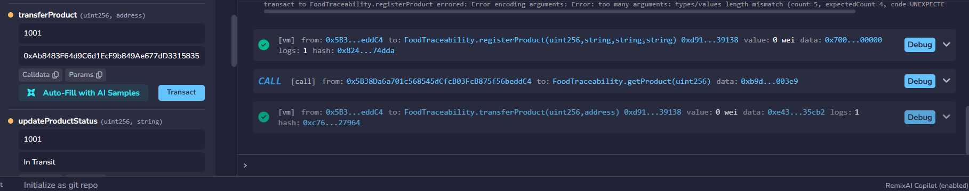

The transferProduct() function was successfully tested using Remix IDE. Product ID 1001 (Gala Apples) was transferred from Account 1 to the specified receiver blockchain address.

Checking With Account 2 Transfer :
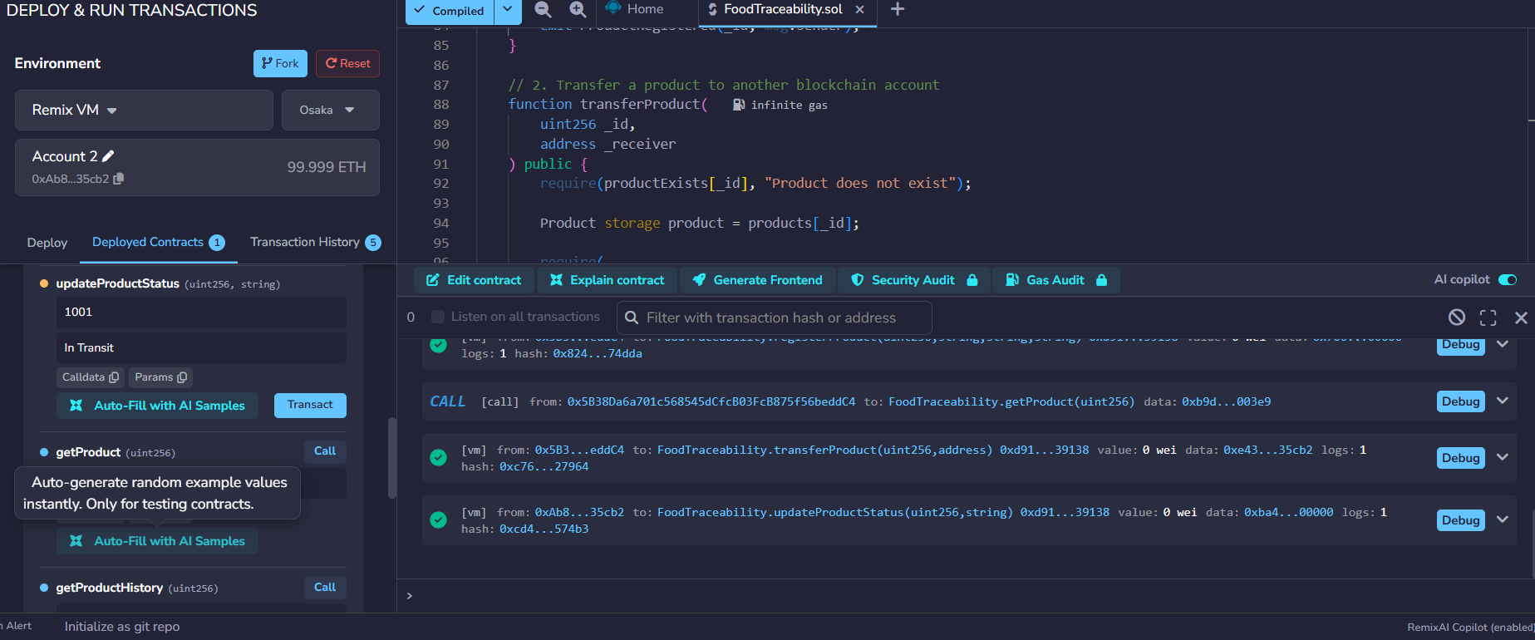
The updateProductStatus() function was successfully tested in Remix IDE using Product ID 1001. After the product ownership was transferred to Account 2, the new owner updated the product status to In Transit.
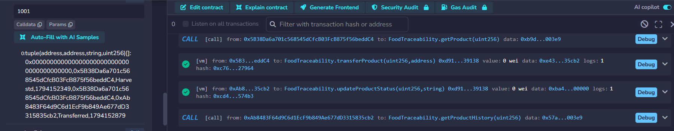
ID 1001. The smart contract returned two records showing the product's initial registration and subsequent ownership transfer.
Checking Unauthorised Transactions

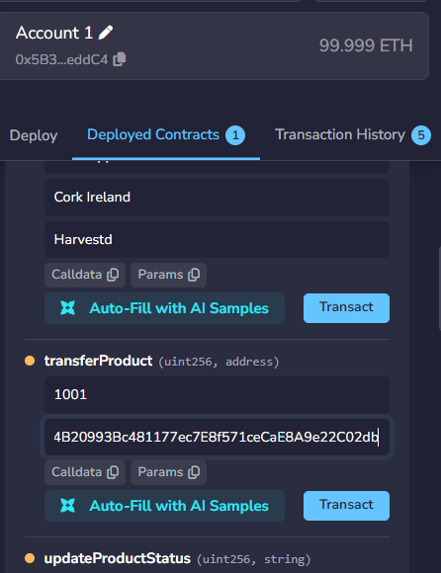
Using Account 1 and copying Account 3 address and testing :
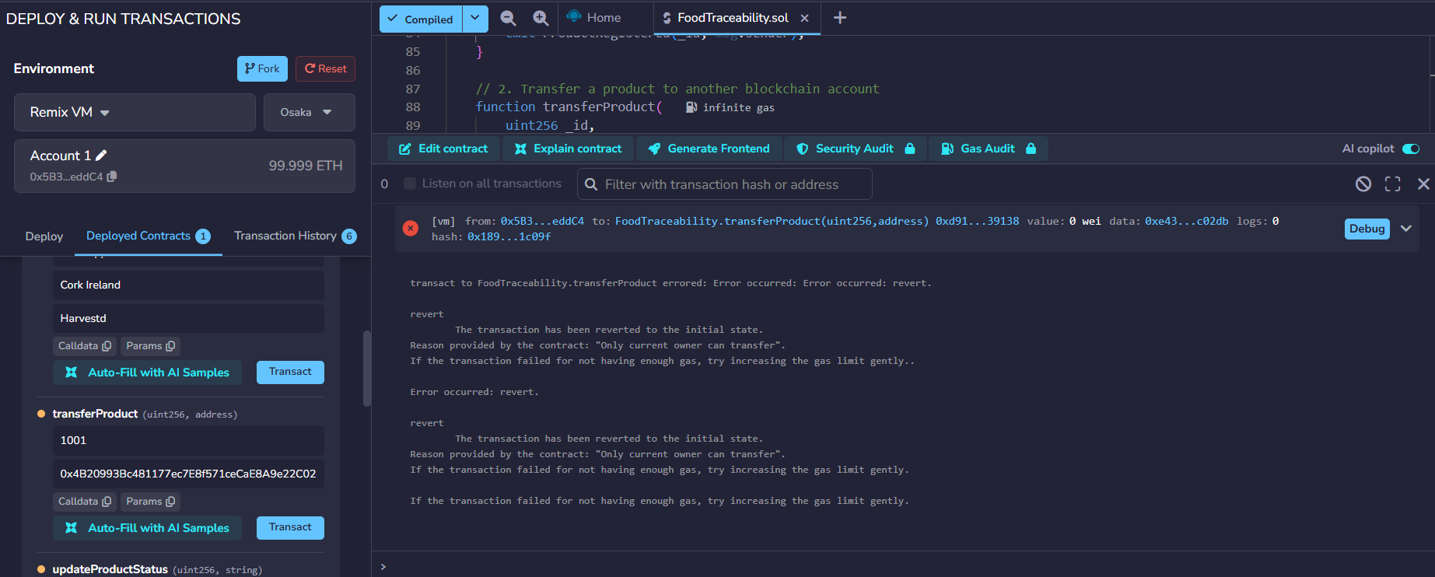

The security validation test was done through the Remix IDE transferProduct() function. Account 1 tried to transfer Product ID 1001 to another blockchain address when it was already transferred to Account 2.
Only the current owner can transfer - the transaction was rejected by the smart contract. This will ensure that a product cannot be transferred by previous owner/accounts and other unauthorized accounts. The transaction was rolled back and the ownership remained the same.

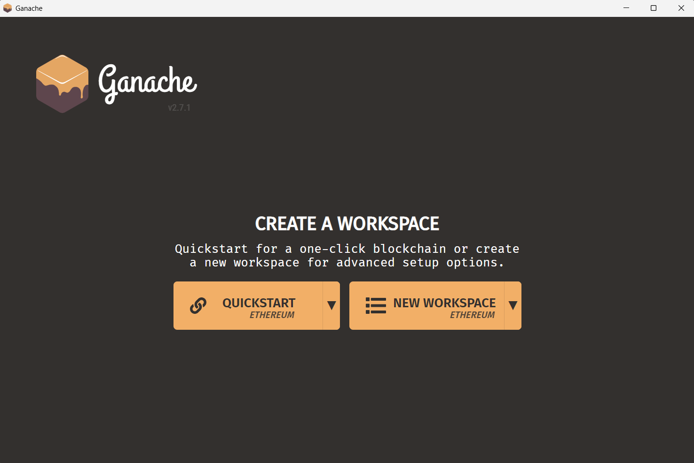
Connecting Ganache :
connected With Remix External Http:
Ganache RPC URL: http://127.0.0.1:7545.
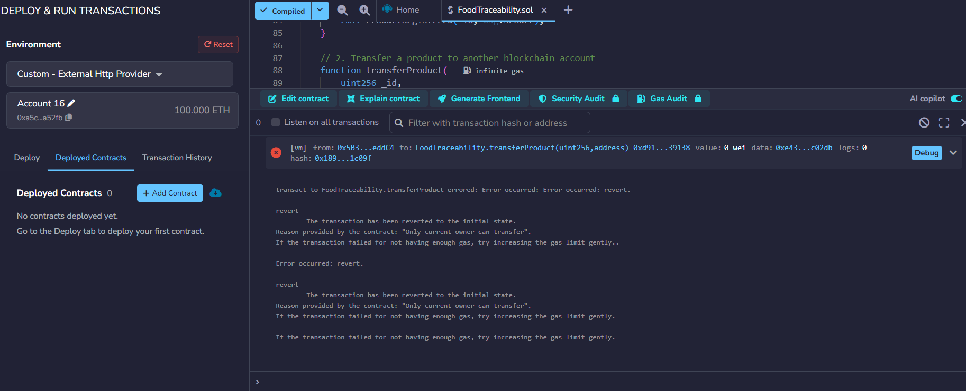

Successful Smart Contract Deployment on Ganache Blockchain
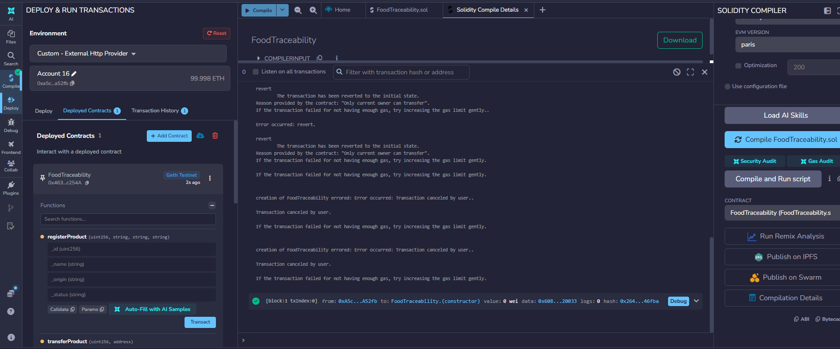
The FoodTraceability smart contract was successfully deployed to a local Ethereum blockchain using Ganache and Remix IDE. Remix used an external HTTP provider for the connection with Ganache, the Solidity contract was compiled with the Paris EVM version for compatibility.

The deployment was successful and an instance of the smart contract was deployed on the local blockchain. Remix confirmed the transaction and showed the address of the contract deployed, so for more testing of the product registration, transferring of ownership, and transaction history.
Testing Ganache Product Registration
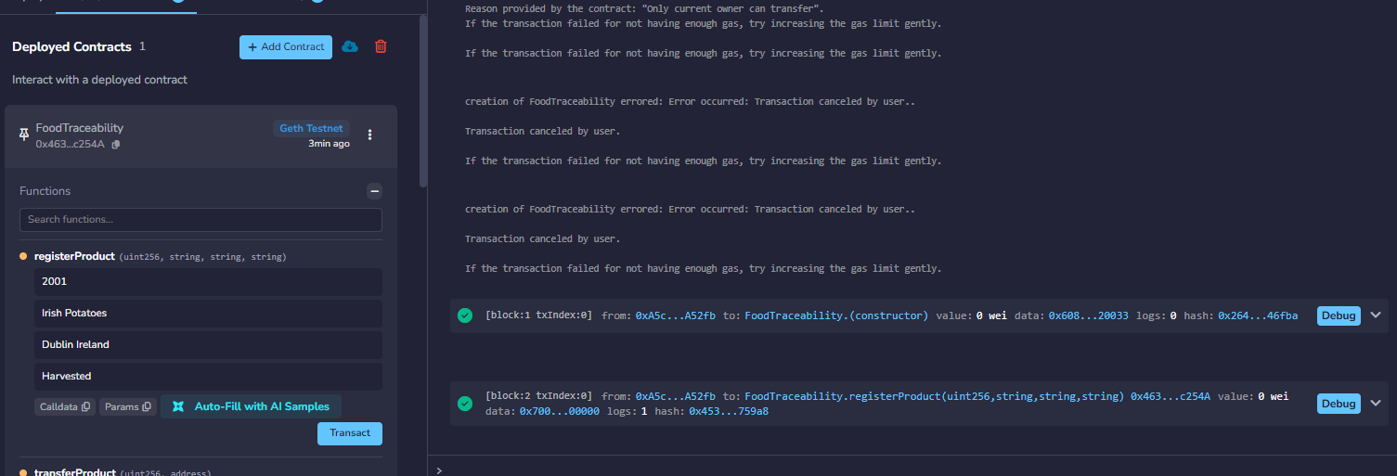
The registration is successful with Ganache.

Verification of Blockchain Transactions Using Ganache Below :

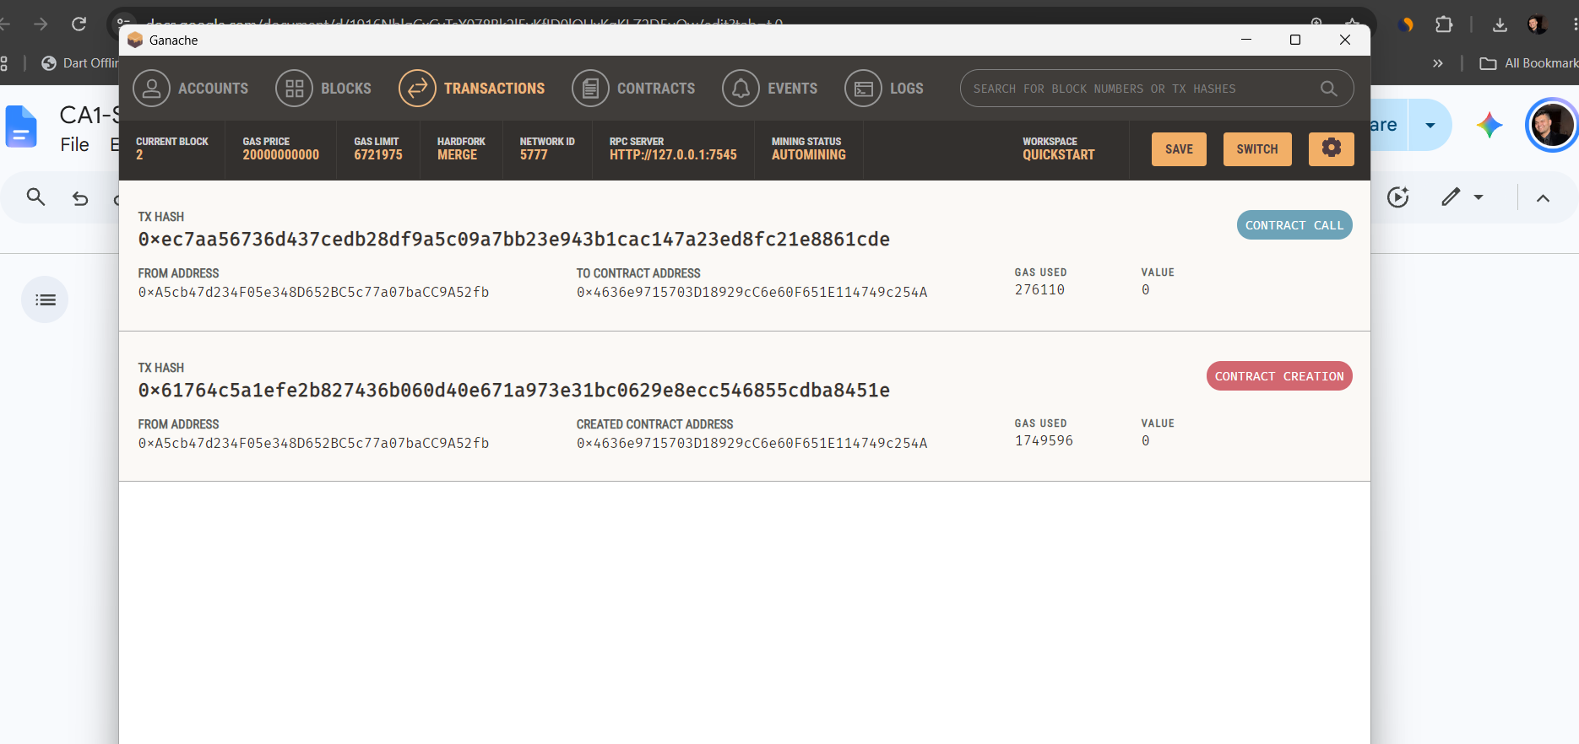
Successful Product Registration on the New Ganache Blockchain

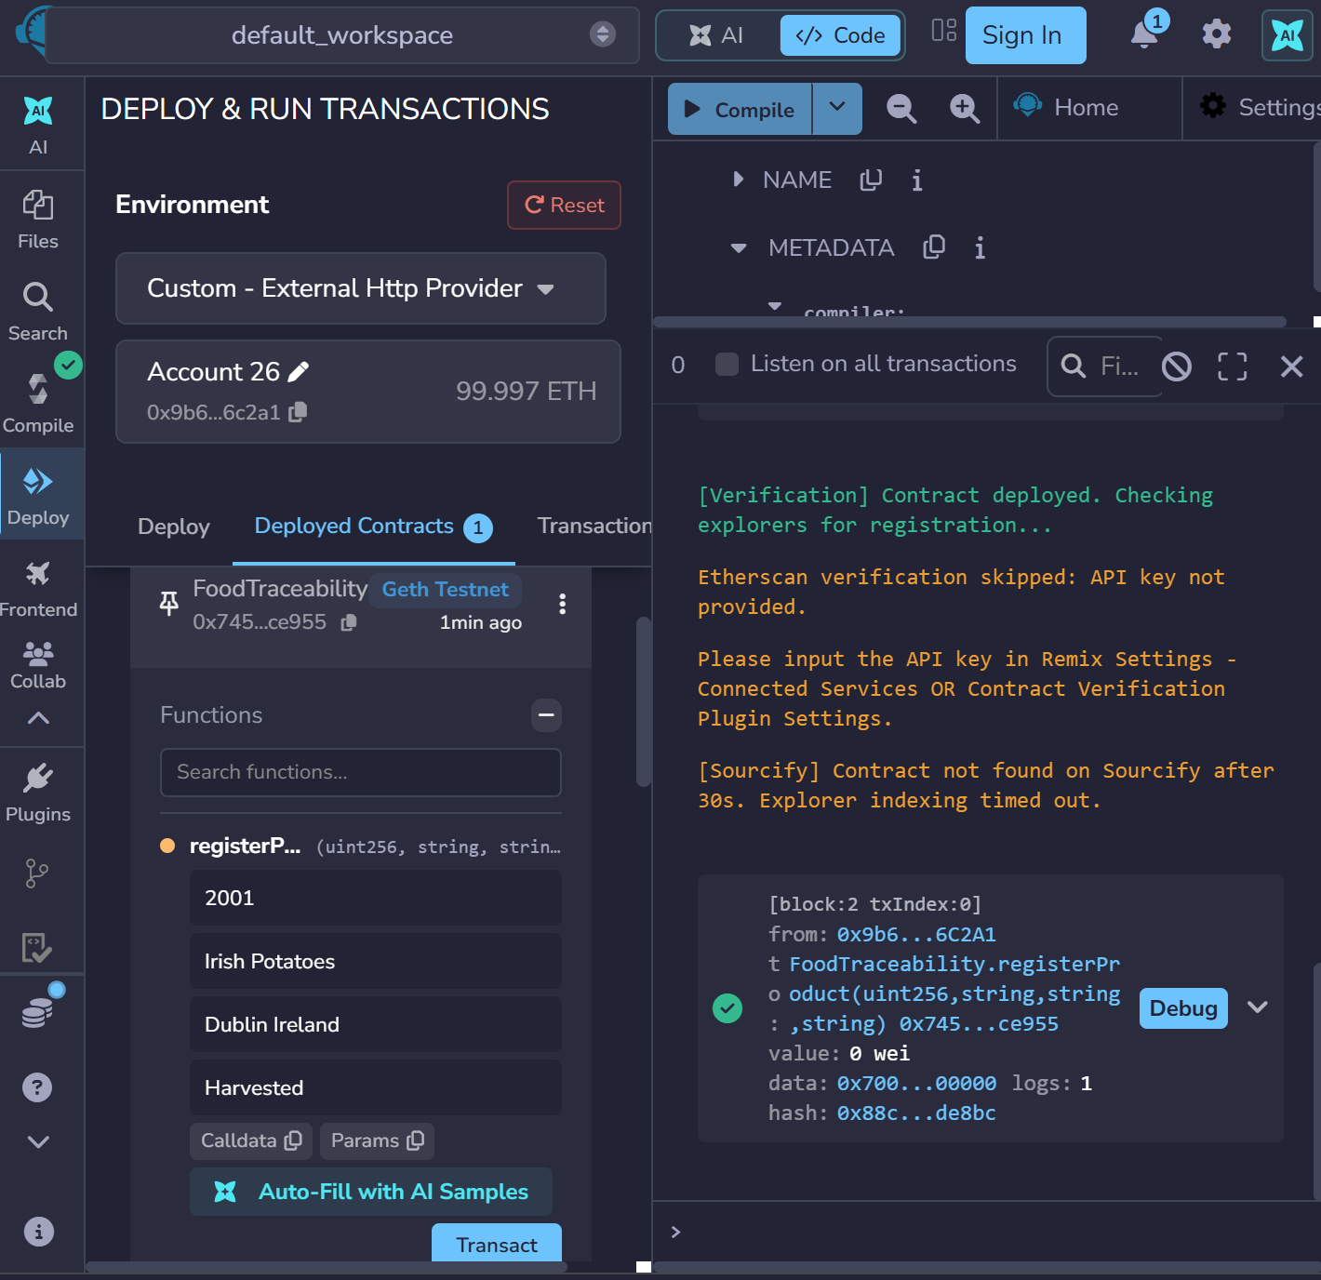The FoodTraceability smart contract was deployed and tested using Remix IDE connected to a local Ganache blockchain. Product ID : 2001 was successfully registered as Irish Potatoes , originating from Dublin Ireland, with the initial status “Harvested”.
Registration was Confirmed In Block 02

Verification of Product Information and Transaction History on Ganache

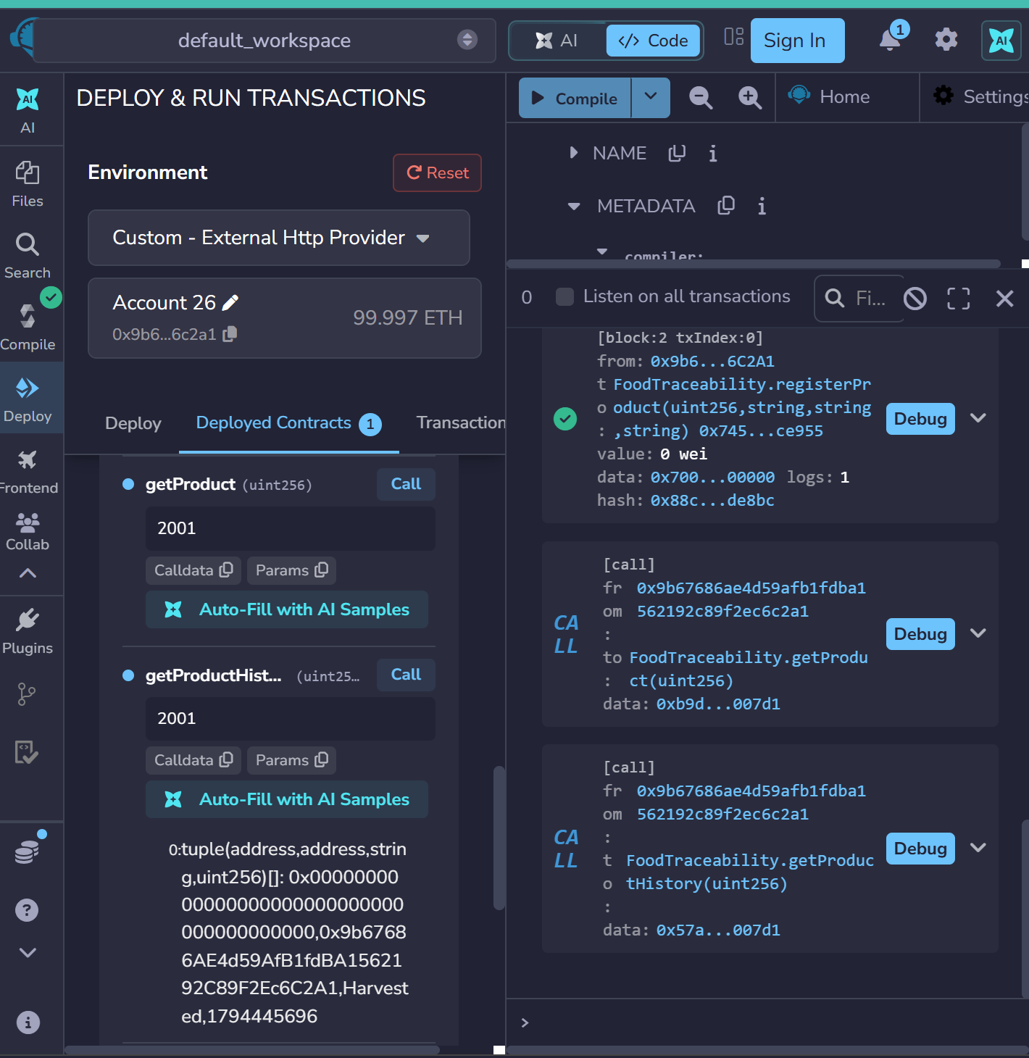
These two functions, getProduct() and getProductHistory(), were tested with Product ID 2001 and Remix IDE connected to Ganache. The returned product history contains the first registration record, which shows the registering account, the product status "Harvested" and the blockchain timestamp.
These functions can only be called and do not change the blockchain data, allowing product information and transaction history to be retrieved without changing blockchain records.
— —-- —-- —-- —--- - - - - - - - -
The concept of Smart Contract Testing: Failed Transaction and Successful Resolution is introduced.Smart Contract Testing: Failed Transaction and Successful Resolution is introduced.
At first when trying to test the function “transferProduct()”, I tried to transfer the Product ID 2001 (Irish Potatoes) from the same blockchain address to the same blockchain address as the sender.
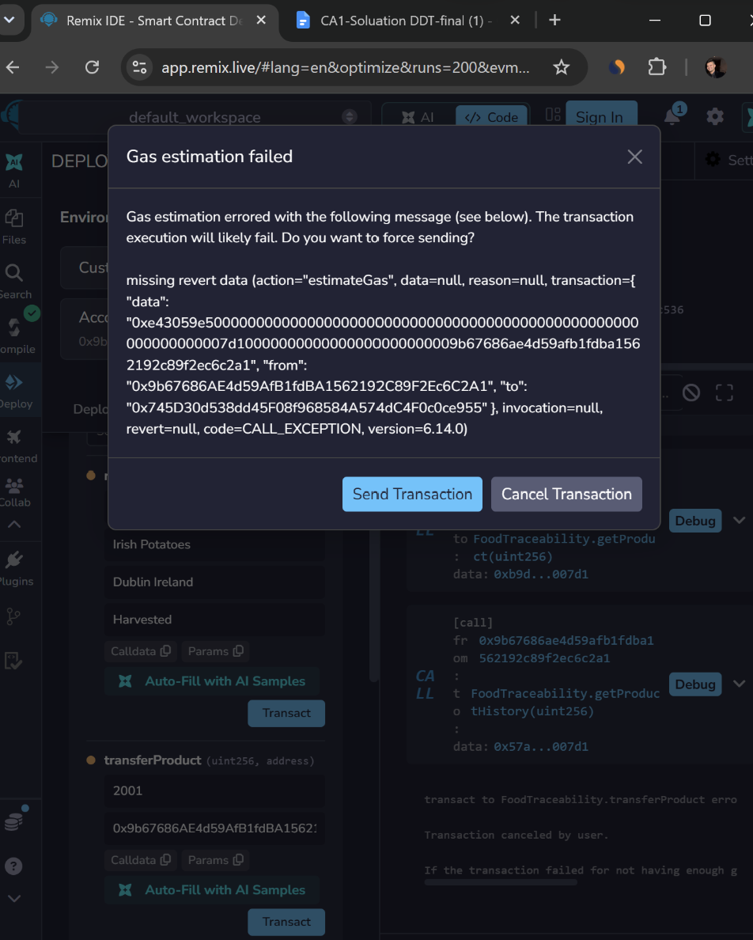
The transaction was likely to be reverted as Remix showed a gas estimation failure. I checked the wallet addresses that had been entered into my wallet and the validation rules in my smart contract to find the issue.

Investigation and Solution

Found that the receiver address matched the selected sender account. A smart contract that I have created has a validation rule that does not allow a product to be moved to its current owner.
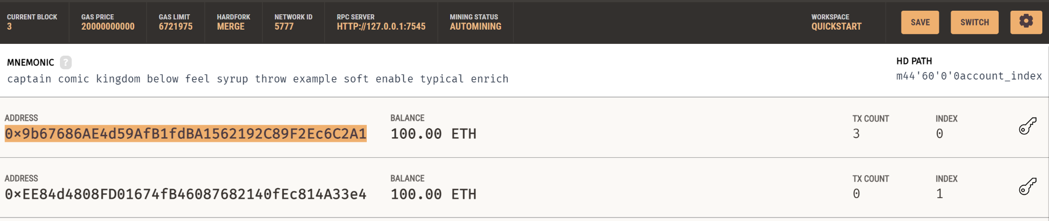next
Because of this, I left the original account as the sender and changed the receiver account address to another Ganache test address to address the problem. I then did the transfer again.

Final Result
The second try went through and has been written into the Block 3 of the Ganache blockchain. Remix displayed a successful transaction, a transaction hash and one event log.
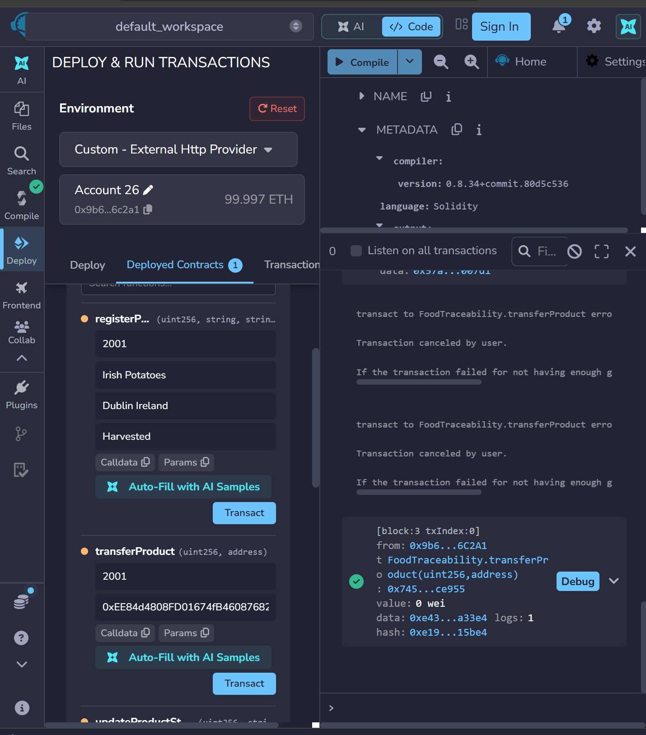
This test process showed how the smart contract validation process would work to ensure that there are no invalid ownership transfers. It also was helpful to me to see how to check wallet addresses, how to see why transactions failed or how to troubleshoot a blockchain transaction before deploying or executing it once again.

Verification of Updated Product Ownership on Ganache
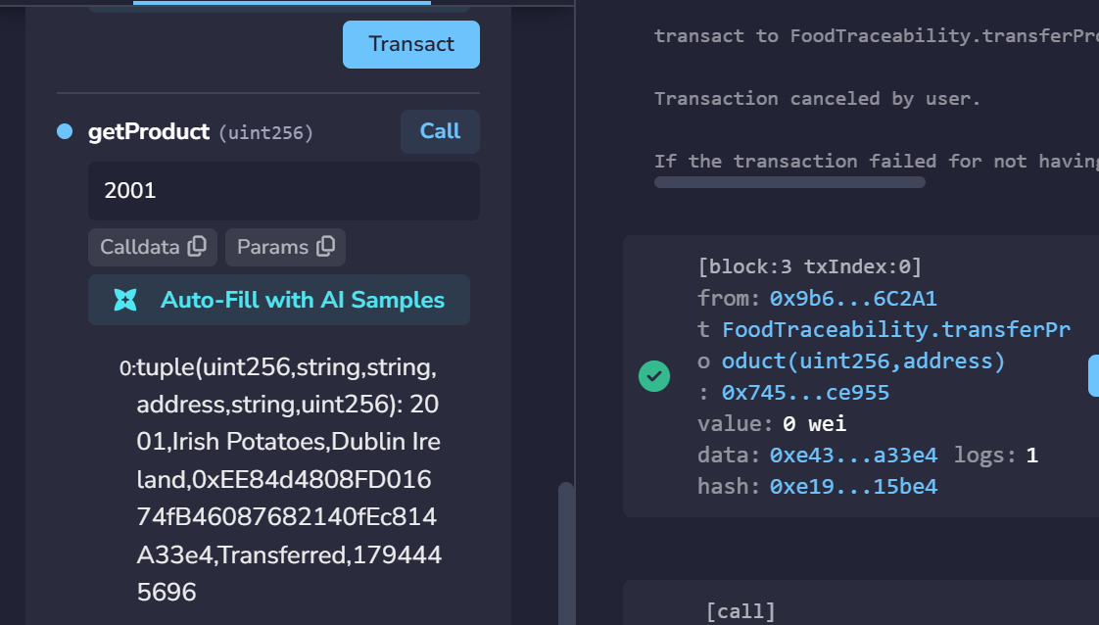
Once the transfer test was successful, I got the Product ID 2001 from the Ganache blockchain using the getProduct() function. The returned data confirmed that the current owner's address changed to the receiver's address and the product status changed to Transferred.
This shows that smart contract correctly changes the owner of the product and that the new information can be retrieved later without changing the blockchain's data.

Product Transaction History Verified
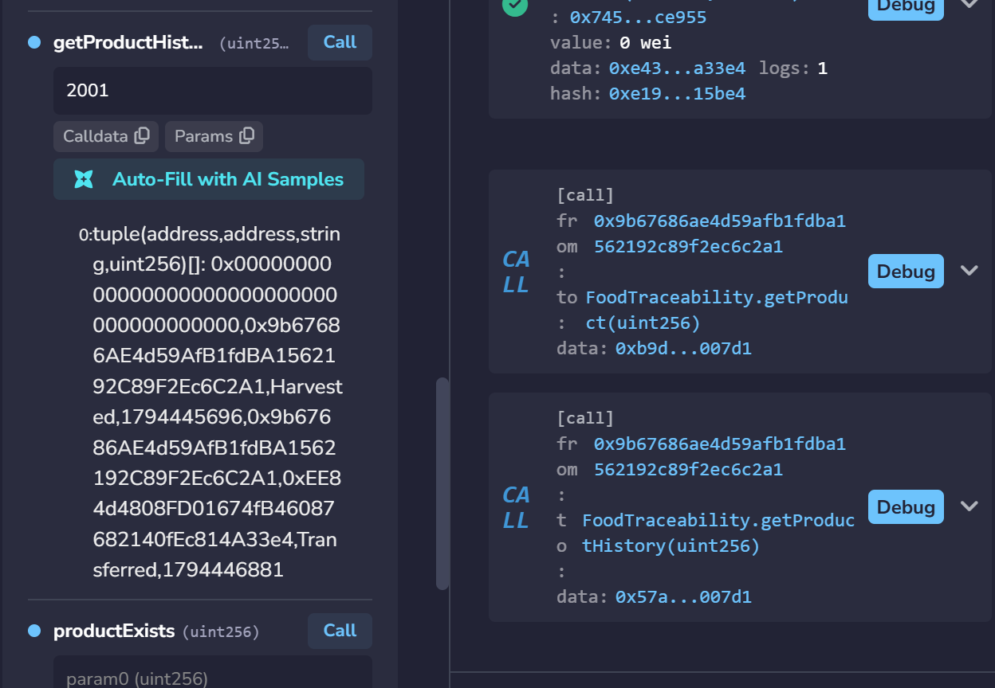
The getProductHistory() function successfully retrieved two blockchain records for product ID 2001: initial registration and ownership transfer.Both records contain sender and receiver addresses, product status and timestamps, confirming successful transaction tracking.

Video Link :
Poster shown and System proof added duration 4.46 mn,please Copy the link and paste it to the new tab to view.
https://docs.google.com/videos/u/0/d/1YKwHBG19r3qew5JTEiIsKVfyxpv5WKZHSu6mj6nb0FI/play?usp=chrome_extension_sharing

Reference:
- “The Ethereum Foundation (n.d.) Ethereum documentation. Viewed at: https://ethereum.org/en/developers/docs/ (Accessed: 12 November 2026)”.
- Solidity Team. (n.d.). Solidity documentation. This guide can be found at: https://docs.soliditylang.org/ (Accessed: 12 November 2026).
- Remix Project (n.d.) Remix IDE documentation. This is found at: https://remix-ide.readthedocs.io/ (Accessed: 12 November 2026).
- Truffle Suite (n.d.) Ganache. Accessed: 12 November 2026. URL: https://archive.trufflesuite.com/ganache/
- Balsamiq (n.d.) Balsamiq Wireframes. According to the authors, Balsamiq is a free application available online at the following website: https://balsamiq.com/ (Accessed: 12 November 2026).

